**P6GC:**

**Overview**

* 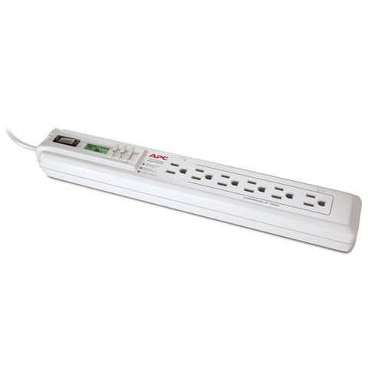

**APC Power-Saving Timer Essential SurgeArrest P6GC**

The APC Power-Saving Timer Essential SurgeArrest P6GC protects your electronic devices from dangerous surges and spikes. This 1,080-joule surge protector features six surge-protected outlets, so you can simultaneously connect multiple home or office electronic devices. An easy-to-use LCD timer allows you to program up to six on/off settings to automatically turn devices on and off, helping you save money on your electricity bill. Two LED indicators inform you of any faulty unit or wall wiring issues.  
  
As one of the world’s largest and most respected power protection designers and manufacturers, APC is relied upon daily for power protection and availability. SurgeArrest Home/Office and Performance products offer the maximum level of protection, safety, convenience, and reliability.  
  
**At a Glance:**

* + Protects 6 connected devices from surges and spikes
  + 6 surge protected outlets
  + Easy-to-use, battery-operated LCD timer
  + 6 programmable timers to save energy
  + SurgeArrest Fail Safe mode automatically disconnects devices if unit is damaged
  + EMI/RFI noise filter for better performance of protected equipment
  + 2 LED indicators warn of faulty unit and wall wiring issues
  + Lifetime equipment protection policy of up to $50,000
* 

**Package Contents**

* + APC Power-Saving Timer Essential SurgeArrest P6GC with 3-foot power cord
  + User manual
* 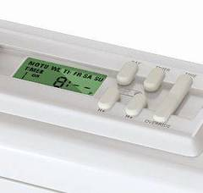

**Multistage Power Surge Protection for Connected Electronics**

The APC Power-Saving Timer Essential SurgeArrest P6GC uses state-of-the art circuitry to protect sensitive electronic equipment from dangerous power surges and multiple surge events such as lightning. Its six surge-protected outlets allow you to simultaneously connect computers, televisions, game consoles, and home theater components.  
  
**Automatically Power Devices On and Off with Programmable Timers**Thanks to an intuitive, battery-powered LCD timer, the APC SurgeArrest P6GC allows users to set up to 6 programmable timers to automatically turn connected devices on and off. This convenient energy-conserving feature saves users an average of $30 a year on their electricity bill.1

* 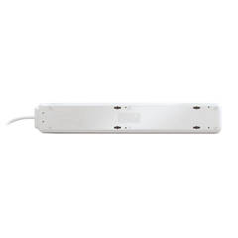

**Fail Safe Mode Keeps Your Devices Protected**

Many other surge protectors will continue to let power through even after their circuits have been damaged, leaving your equipment exposed to future surges. The SurgeArrest P6GC features a Fail Safe mode that automatically disconnects equipment from the power supply if the circuit of the APC SurgeArrest has been compromised, ensuring no damaging surges reach your equipment.  
  
**Noise Filter Reduces Electromagnetic Interference**The noise filter of the SurgeArrest P6GC reduces electromagnetic interference (EMI) and radio frequency interference (RFI) to block unwanted line noise, thus ensuring better performance of protected equipment. It also helps prevent equipment lockup.  
  
**LED Indicators Ensure Your Unit Is Functioning Properly**  
The APC SurgeArrest Essential features a Wiring Fault LED that proactively warns you of potentially dangerous wiring problems in the wall circuit. The Protection Working LED illuminates when the SurgeArrest is switched on and is supplying conditioned utility power to the outlet. It will also notify you if the unit is damaged and needs a free replacement.  
  
**Safety-Agency Approved Protector with Lifetime Warranty**The P6GC has been tested and approved to work safely by a third-party Nationally Recognized Testing Laboratory (NRTL). This surge protector unit is covered by lifetime warranty, with a four-year warranty for the LCD module. It also comes with a lifetime equipment protection policy of up to $50,000. If your SurgeArrest Essential P6GC has been damaged by a heavy lightning strike or power line surge, APC will replace it free of charge.